Name___________________________________

Quick Quiz

**Unit Rate 7**

Identify the unit rate:

1. 6 movie tickets cost $30 2. $y=7x$

**$_________ per ticket unit rate =_________**

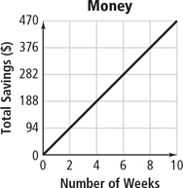

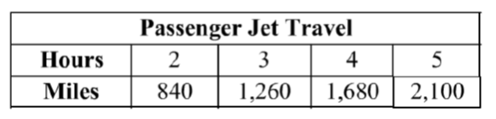3. 4.  **$________**

**per week**

**_________ miles per hour**

____________________________________________________________________________

Corrections

**Unit Rate 7**

Identify the unit rate:

1. 6 movie tickets cost $30 2.

**$_________ per ticket unit rate =_________**



3. 4.  **$________**

**per week**

**_________ miles per hour**